Name: ……………………………. Grade 1 Nour El Maaref private primary school
1- Look at the pictures and write a sentence:
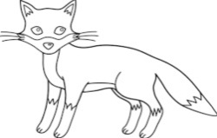
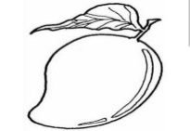

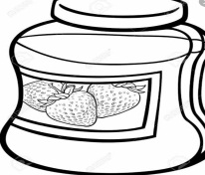
……………………………………………. ……………………………………………

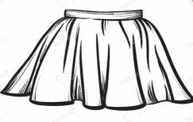


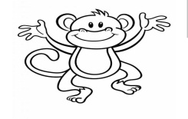
…………………………………………………… ……………………………………………………

………………………..………. …………………………….….
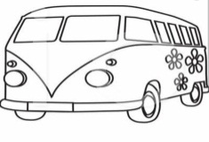


…………………………………. ……………………………………….


2- Choose and circle :
1- He ( am – is ) a vet.
2- ( This – These) are socks
3- It is ( a – an ) elephant .
4- ( How – What ) much is it?
5- ( How – What ) is the time?
6- It's cold and rainy in (summer – winter).
7- It's my ( skirt – pants).
8- It’s ( eleven – thirteen ) o’clock.
9- ( How – What ) is it ?
10- What ( is – are ) these ?
11- I ( am – is ) a soldier .
12- I want to ( be – am - is ) a doctor.
13- The camel lives in the ( sea – desert ) .
14- A T.shirt is made of (fabric – flour).
15-How( much – many) is a watermelon ? – Ten Pounds.
16- ( Is – Are ) these your socks ?
17- ( It – He )’s rainy.
18- The monkey lives in the ( jungle – desert).
19- It’s five ( pounds – socks)
20- No, it ( is – isn't).
21. They (is – are) pajamas.
22. Bread is made of ( flour – fabric)
3- Rearrange the following sentences:

1) to – I – engineer – want – be - an .
………………………………………………………………………………………………………………………………..
2) a – She – is – dentist .
………………………………………………………………………………….………………………………………………
3) am – seven – I - years - old.
…………………………………………………………………………………………………………………………………
4) pounds – ten – ‘s – It .
………………………………………………………………………………………………………..…………………
5) eleven – It – o’clock – ‘s .
……………………………………………………………………………………………….………………………
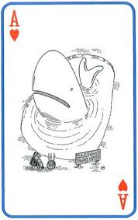
6) is – a – It – skirt – yellow
………………………………………………………………………………………………………..……..……………
7) are – These – shoes – yellow.
……………………………………………………………………………………………………………………………

- your – it – Is – skirt ?
……………………………………………………………………………………………………………………….
- the – is – What – time?
…………………………………………………………………………………………………………
- much – are – dates - the –How?
………………………………………………………………………………………………………………
11) eleven – It – o’clock – ‘s .
………………………………………………………………………………………………………………………………..
12) pyramids – visit – Let's – the .
………………………………………………………………………………….………………………………………………
3. Where does the camel live ?
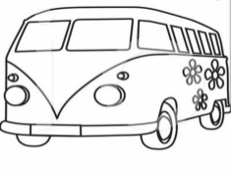
……………………………………………………………………………
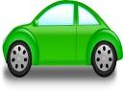
Answer the following questions:
1. What is this?
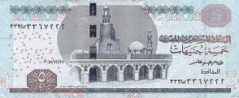
……………………………………………………………………………..……
2. How much is it ?

…………………………………………………………………………………..……
4. Is it sunny ?
………………………………………………………………………
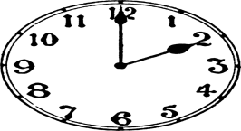
5. What is the time ?
……………………………………………………………………………..……

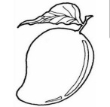
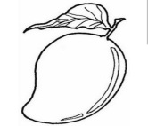
6. What are these ?
………………………………………………………………………….…………….
7. Where does the camel live ? ………………………………………………………………………….……………….
8. Is he a vet ?
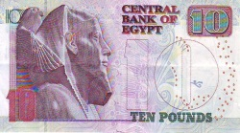
………………………………………………………………………………………………….……
9. How much is the watermelon ?
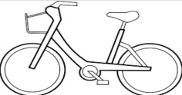
……………………………………………………………………………………………………….….
10. What can you see?
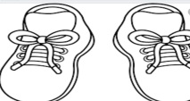
…………………………………………………………………………………………..
11.Are these shoes?
…………………………………………………………………………………………………….

